VGA to DVI-D converter
U S E R M A N U A L

Thank you for choosing our VGA to DVI-D converter.We hope this converter could bring you a perfect visual experiences.Before using it,please read this manual carefully for your better knowledge of all the functionalities of this converter.
Our series of HDMI splitters, switchers, extenders, matrixes and converters are designed to make your A/V device use more convenient ,more comfortable, more productive and more cost-efficient.
Introduction
The VGA to DVI-D Converter changes your computer's analog VGA signal to digital DVI-D video. The converter generates all the compatible analog to digital conversion signals make to connect computers with VGA connectors to digital DVI-D monitors or projectors.
. No driver or software required and suiable for all DVI formats. Perfect for projectors,gaming consolers or other high definition video equipments.

Functions
※ Supports DVI 1.1;
※ Supports Input signal(VGA)Resolution: Up to 1920*1080@60Hz.
800*600@60HZ,1024*768@60HZ,1280*720@60HZ,1280*800@60HZ,1280*1024@60HZ,1366*768@60HZ,1440*900@60HZ,1600*1200@60HZ,1680*1050@60HZ,1920*1080@60HZ；
※ Supports up to 1920*1080@60Hz, same format as input
※ External power from DC5V@1000MA;
※ Pure hardware design,just Plug-and-play No software or driver requiremen;
※ Industry-level design(size:110x75x22mm);
※ Weight:180g
Interface function:
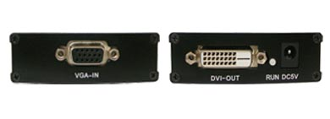

Item | Spec.
VGA-IN | Connect VGA Source
DVI-D OUT | Connect DVI-D monitors or projectors
RUN | Power Indicator
DC5V | Connect DC5V/1A power supply
Connection Image
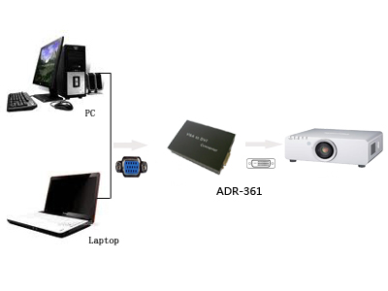
Product Parts List(standard configuration)

Parts Name | Quantity | Notes
VGA to DVI-D converter | 1
Power Adapter | 1 | DC5V/1A supply
User`s Manual | 1

