USER’S
MANUAL

Industrial Monitor Converter

(CGA/EGA/RGB to VGA)

Model: ADR-8219

ADEERI Technology Co.,Ltd
Apr 2010

Copyright Notice and Disclaimer
All rights reserved. No parts of this manual may be reproduced in any form without the express written permission of ADEERI Technology Co., Ltd(ADEERI) makes no representations or warranties with respect to the contents hereof. In addition, information contained herein are subject to change without notice. Every precaution has been taken in the preparation of this manual. Nevertheless,ADEERI assumes no responsibility for errors or omissions or any damages resulting from the use of the information contained in this publication.

ADEERI is a trademark of ADEERI Technology Co., Ltd.
All other trademarks belong to their respective owners.

1. Important Info
Before start this product, please read the User’s Manual carefully, it contains all product-related warnings and important issues.
Do not try the followings:
- unauthorized repairs or parts replacement or other operations
- inappropriate placement including but not limited to lightning, fire, exposure to rain, water, gas
- switch to the power not in the voltage allowable range
- remove the modified label or the warranty label

Cautions:

 | WARNING | 
WIZARD GAME
DO NOT UNCOVER
To avoid electric shock, do not uncover the metal case, unauthorized repairs or parts replacement or other operations are prohibited. Please return to factory for repair.

2. Features
ADEERI Technology Co. , Ltd (ADEERI) in the industrial equipment under long-term maintenance and reconstruction of the monitors& display systems on the lessons learned to gather requirements and feedback of many customers, after many years of development and testing, based on the strength in ADR-8218 launch of innovative industrial monitor converter – ADR-8219, it achieved Industrial video signal(RGB/CGA/VGA to VGA) conversion fully automated operation, will give you the maintenance and replacement of industrial display to bring about affordable price and convenient.

- Feature specifications

Input | Signals | MDA、CGA、EGA、RGB、RGB Sog、RGBS、RGBHV、YPbPr
Input | Interface | 9pin、3pin、6pin、14pin、20pin、25pin
Input | Horizontal Frequency Rate(H) | 12kHz to 40kHz  automatically recognized
Output | Supports | 15pin VGA，Resolution:800*600/60HZ  or custom-resolution
Output | Interface | D-Sub 15 PIN standard VGA port
Power | DC 12V 1.0A

Note:
1.YPbPr = YUV
2.Input Horizontal Frequency Rate 12kHz to 40kHz automatically recognized.
3.Support RGB and YPbPr
4.Support Interlaced Scanning and Line by Line Scanning.
5.Support Vertical Resolution from line200 to line 600 automatically recognized.
6.Support variable Horizontal Resolution automatically recognized。
7.Support RGBHV (separate sync) ,RGBS (composite sync), automatically recognized
8.Output resolution: 800*600/60Hz standard VGA or custom-resolution.

3. Interface Specification

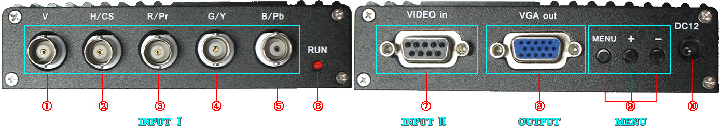

Item | Spec. | Remarks
① V | To connect V interface of the input device | Input Channel Ⅰ
② H/CS | To connect H(CS) interface of the input device | Input Channel Ⅰ
③ R/Pr | Red signal input/ Pr signal input | Input Channel Ⅰ
④ G/Y | Green signal input/ YPBPR -Y signal input | Input Channel Ⅰ
⑤ B/Pb | Blue Signal input/YPBPR -Pb signal input | Input Channel Ⅰ
⑥ RUN | Running Status Indicator
⑦ VIDEO in | To connect 9-pin interface of the input device | Input Channel Ⅱ
⑧ VGA out | Standard sub-15p VGA female interface | VGA Output
⑨ MENU | Use to adjust screen /programming
⑩ DC12 | Power input DC12V, 1A
Note: Input Channel Ⅰ, Input Channel Ⅱ, you can choose one of them

4. Definition for I/O interface

Table 4.1 Definition for Input Channel Ⅱ:
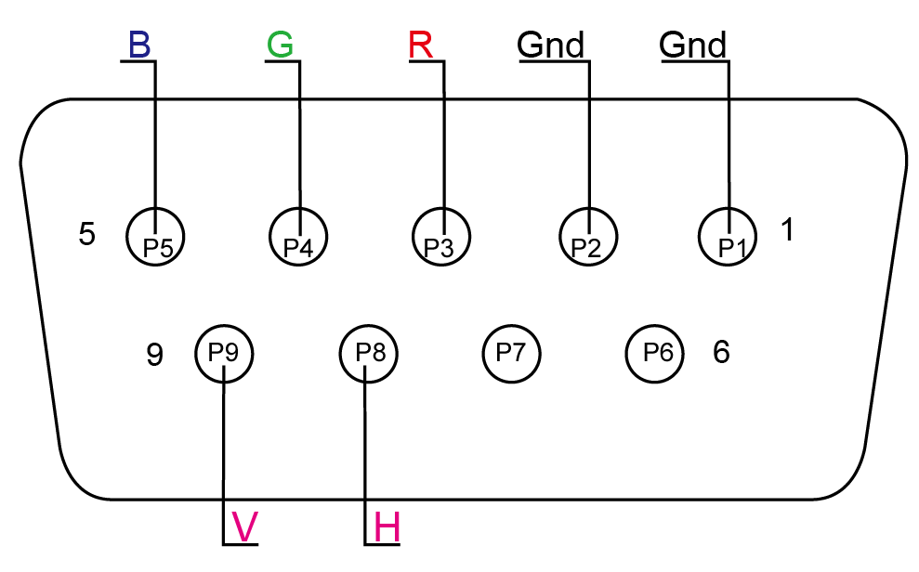
PIN | Input Signal
p1(GND) | Connect to the ground
p2(GND) | Connect to the ground
P3(R) | connect R(ed) interface of the input device
P4(G) | connect G(reen) interface of the input device
P5(B) | connect B(lue) interface of the input device
P6 | Undefined(null)
P7 | Undefined(null)
P8(H) | connect H(CS) interface of the input device
P9(V) | connect V interface of the input device

Figure 4.1 Definition for Input Channel Ⅱ

Table 4.2 Definition for Input Channel Ⅰ
BNC | Input Signal | Connection image
Pb、Y、Pr | YPbPr input signal (right image)  Interface: three BNC slot, connected to the corresponding Pb, Y, Pr interface, then Y monochrome port. | 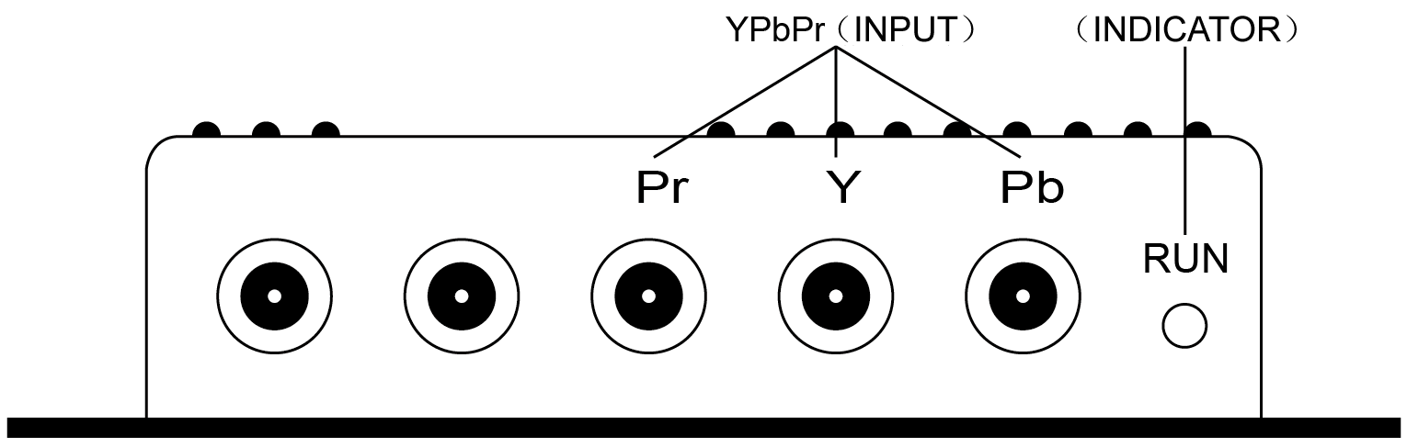  Figure 4.2 Analog 3BNC (YPBPR) Input.
R、G、B | RGB Sog input signal (right image)  Interface: three BNC slot, connected to the corresponding R, G, B slot, then G monochrome port. | 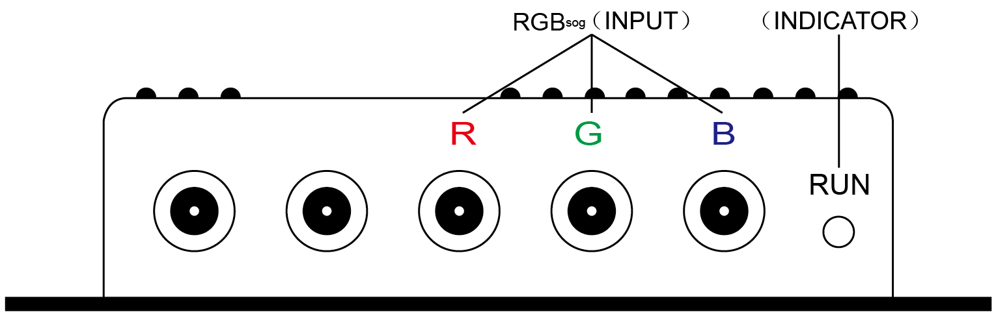  Figure 4.3 Analog 3BNC (RGB Sog) Input.
R、G、B、S | RGBS CS Composite Sync (right image)  Interfaces: 4 BNC slot, connected to the corresponding R, G, B, S I, monochrome then G, S I | 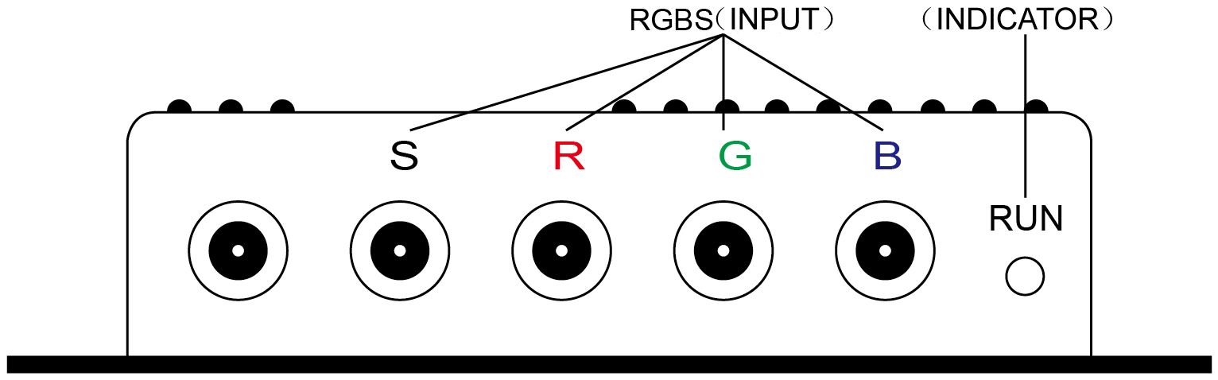  Figure 4.4 Analog 4BNC (RGBS CS) Input.
R、G、B、H、V | RGBHV separate sync (right image)  Interface: 5 BNC port, connected to the corresponding R, G, B, H, V I, monochrome then G, H, V I | 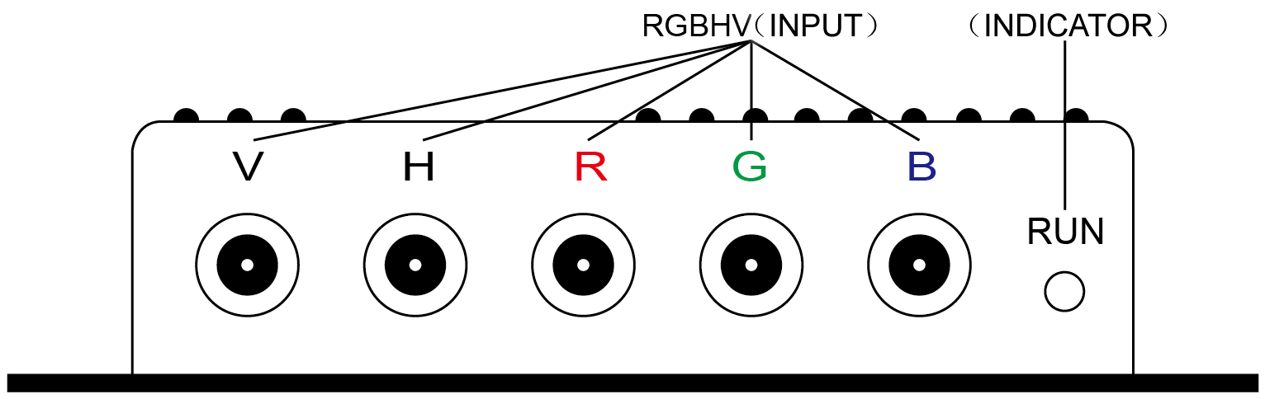  Figure 4.5 Analog 5BNC (RGBHV) Input.

5. Operation Menu
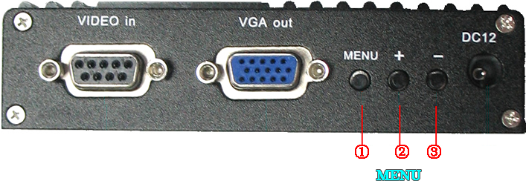
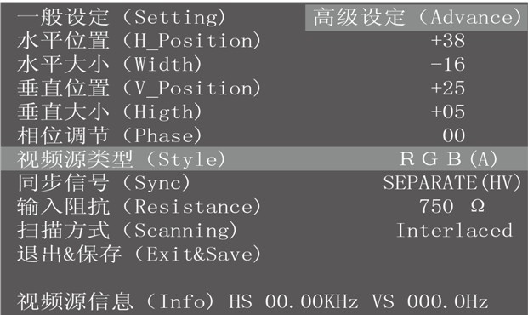

Item | Spec.
①MENU | -press it to enter into OSD menu  -click it once to select and click again to exit the current line
② “+” | -click it to move the cursor up  -click it to add the value
③ “-“ | -click it to move the cursor down  -click it to deduct the value

6. Accessories& Details

Table 6.1 Accessories list
Item | QTY | Remarks
User’s Manual | 1 | English
Power Adaptor | 1 | DC12V,1A
half 9pin cable | 1
9pin M-F cable | 2 | 1 Male + 1 Female

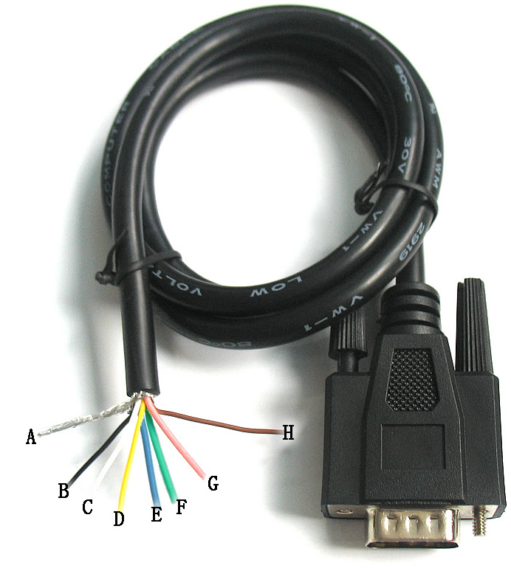
Table 6.2 Details of half 9Pin cable
Name | Wire color | Signal
A | Silver web | Shield
B | Black wire | Ground(GND)
C | White wire | Vertical Frequency Rate(V)
D | Orange wire | Horizontal Frequency Rate(H)
E | Blue wire | Blue(B)
F | Green wire | Green(G)
G | Red wire | Red(R)
H | Brown wire | Undefined(null)

Figure 6.2 Half 9pin cable

7. Assembly and debugging
Step 1: access signals, if not display or display color is not correct, adjust the video source type items, adjusted to the input video signal with the same type, color, only the normal display. (Available options are: YUV color, RGB (D) digital TTL signals, RGB (A) mode may signal)
Step 2:The system can automatically identify the signal. If you adjust the first step, the image color display is no need to manually adjust the normal; if there distortions in the image, you need to manually adjust the synchronization signal and the signal source to adjust to the same types of synchronization, you can normally display.
Step 3: If the screen shows elongated, and the overflow to the bottom of the screen, put the adjusted scanning: Progressive Scan (Progressive); if the adjustment of the vertical position to a maximum, the image display is still only half of the display, put the adjust the scanning mode: interlaced scan (Interlaced).
Step 4: Adjust the horizontal position, horizontal size, vertical position, vertical size of the items, adjusted to the satisfaction of the location.
Step 5: input impedance, select the input source impedance than with select 750 in Europe, relatively light, if you choose all 750 European white side, you should choose for the 75 euro.
Step 6: the phase adjustment, if the image appears small waves up and down type jitter, can adjust the consistency with the input signal phase.
Step 7: Save and Exit: Save all the parameters and exit the menu.

